Ques 1:

Create your own new custom VPC

- And configure your EC2 linux instance inside your custom VPC

- and then create 3 subnets of that VPC

- Attach an internet gateway to your custom VPC

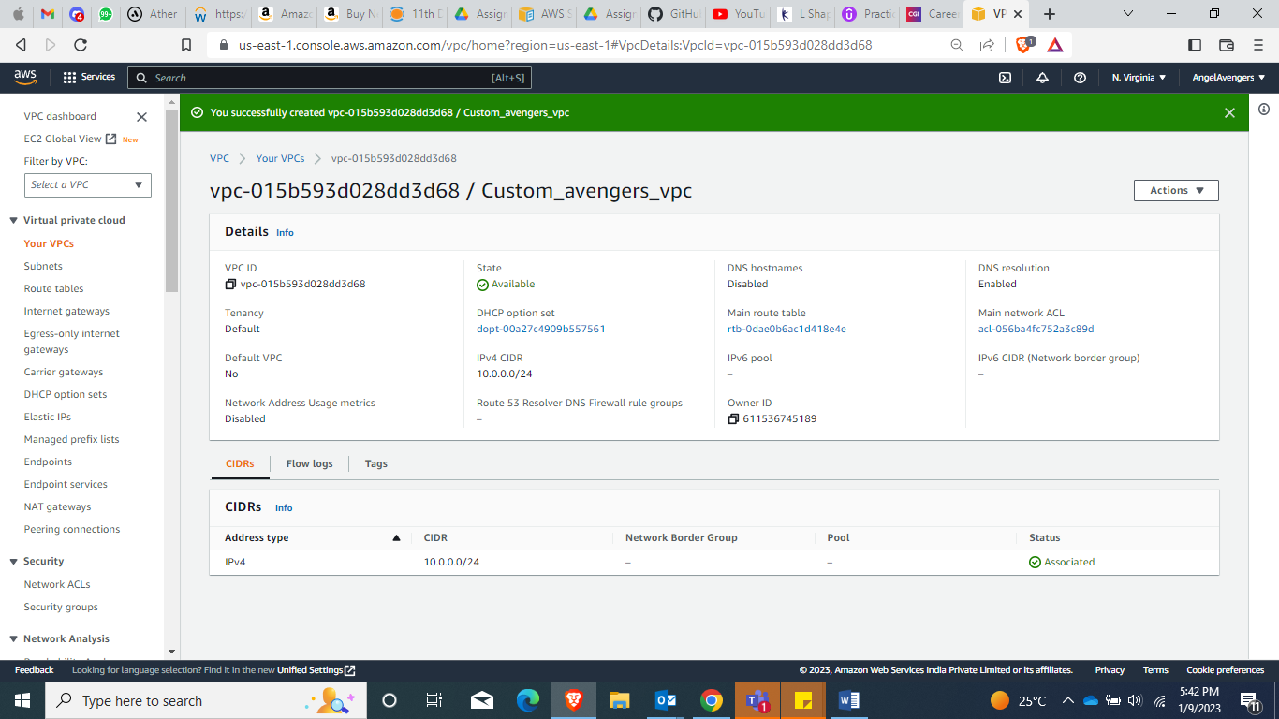

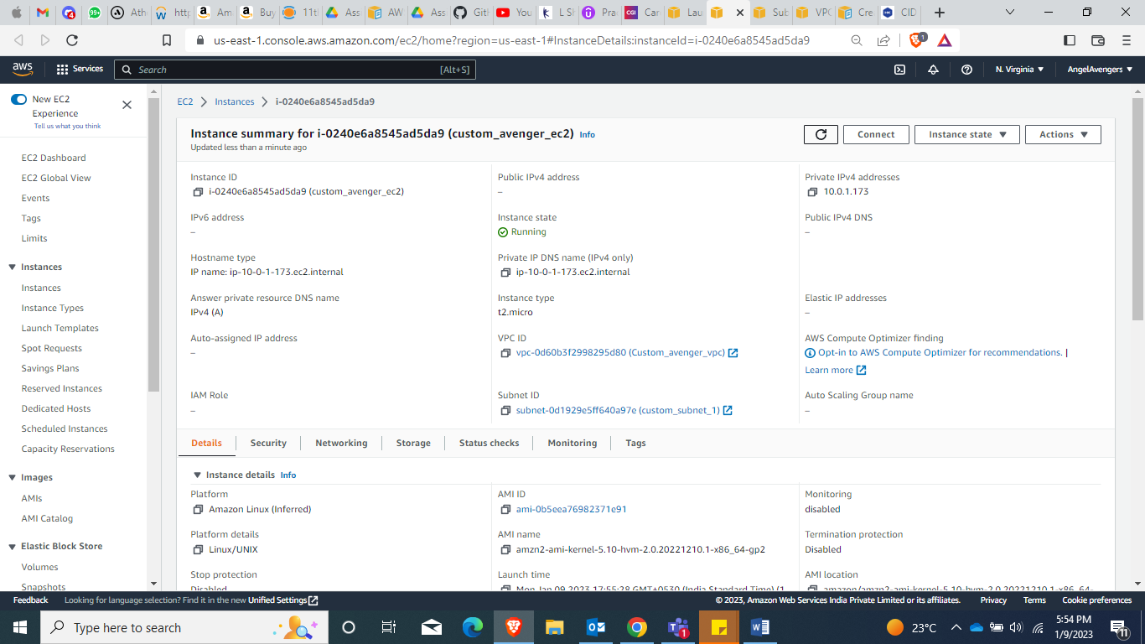

3 subnets created in 3 az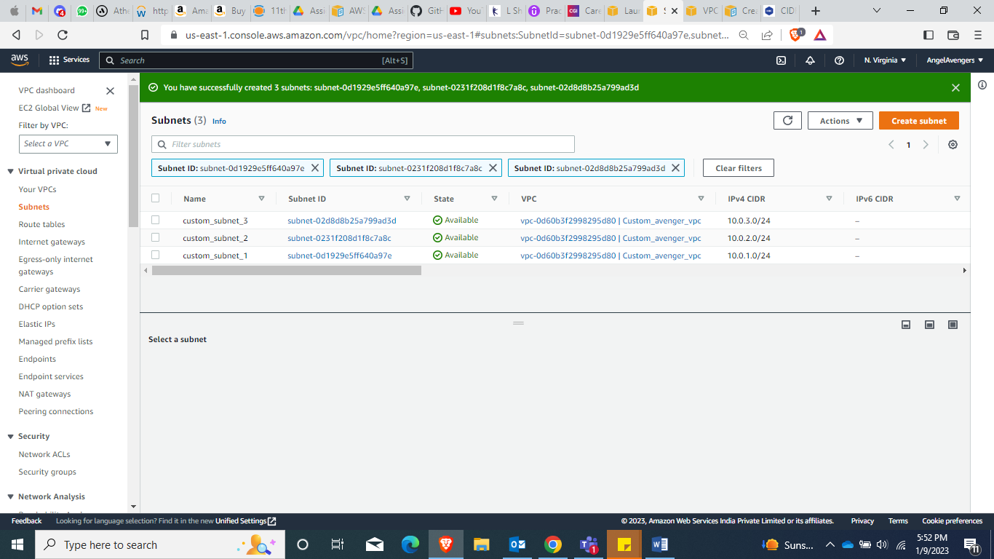

All 3 subnet are visible while creating EC2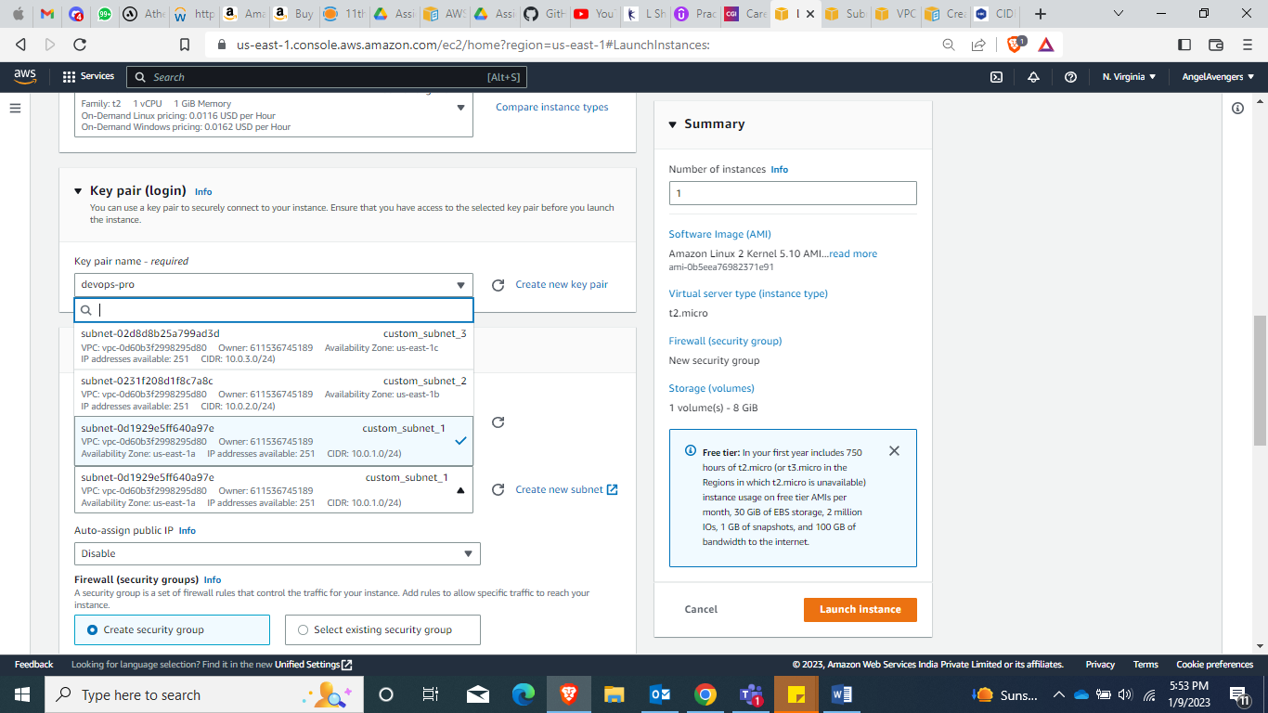

Internet Gateway